
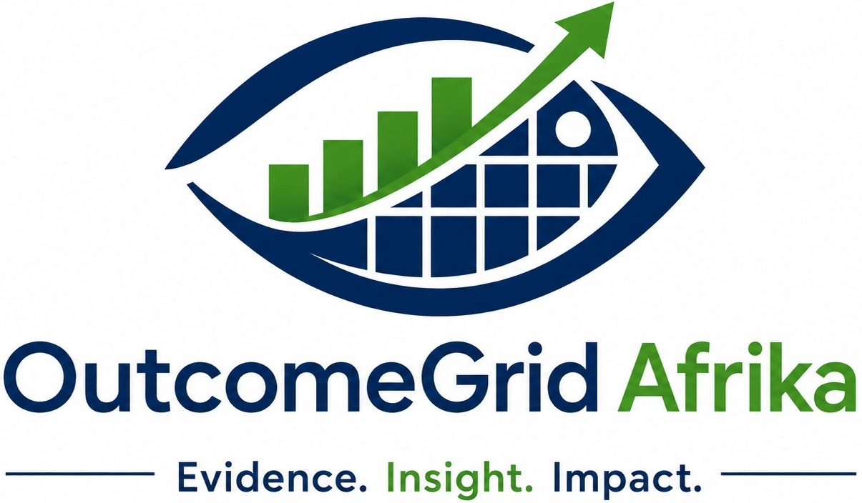

COMPANY PROFILE
Evidence. Insight. Impact.
Research | Monitoring & Evaluation | Data Analytics | Capacity Building | Digital & AI Solutions
P.O. Box 100523, Kasangati, Wakiso, Uganda | www.outcomegridafrika.com

TABLE OF CONTENTS
1. CORPORATE STATEMENT 3
2. ABOUT OUTCOMEGRID AFRIKA 4
3. VISION, MISSION AND CORE VALUES 5
4. OUR SERVICE AREAS 6
5. SECTOR EXPERIENCE 7
6. OUR METHODOLOGICAL APPROACH 8
7. WHY CHOOSE OUTCOMEGRID AFRIKA 9
8. LEADERSHIP PROFILE 10
9. SELECTED ASSIGNMENTS AND EXPERIENCE 11
10. STRATEGIC PARTNERSHIPS 12
11. CONTACT INFORMATION 13

(Right-click the section above and choose "Update Field" in Word to populate page numbers.)

1. CORPORATE STATEMENT
OutcomeGrid Afrika Limited is a multidisciplinary consulting and advisory firm dedicated to helping organisations generate evidence, derive actionable insights, and achieve measurable impact. We specialise in research, monitoring, evaluation and learning (MEL), data analytics, digital transformation, artificial intelligence solutions, organisational development, and capacity building.
The firm supports governments, development partners, non-governmental organisations, academic institutions, private sector entities, and community organisations across Africa in strengthening decision-making, improving programme performance, enhancing accountability, and promoting sustainable development outcomes.
Our multidisciplinary approach combines rigorous research methodologies, advanced analytical techniques, innovative digital technologies, and practical implementation experience to provide solutions that address complex development and organisational challenges.
“At OutcomeGrid Afrika, we believe that evidence should drive decisions, data should generate insight, and innovation should create impact.”

2. ABOUT OUTCOMEGRID AFRIKA
OutcomeGrid Afrika Limited was established to bridge the gap between data, evidence, technology, and decision-making. The firm brings together expertise in monitoring and evaluation, research, statistics, data science, information systems, project management, digital innovation, and artificial intelligence to provide integrated solutions for organisations operating in increasingly complex environments.
Our work is guided by international best practice and global standards, which anchor every assignment we undertake:

OECD-DAC CRITERIA | RESULTS-BASED MGT (RBM) | THEORY OF CHANGE
LOGICAL FRAMEWORK APPROACH | SDGs | AI GOVERNANCE FRAMEWORKS

3. VISION, MISSION AND CORE VALUES
OUR VISION
To be Africa's leading evidence-driven consulting firm advancing sustainable development, organisational excellence, and digital transformation through innovative research, analytics, and artificial intelligence solutions.

OUR MISSION
To empower organisations and communities through research, monitoring and evaluation, data analytics, digital solutions, and capacity building that enhance decision-making, strengthen institutional performance, and deliver measurable and sustainable impact.

Our Core Values
  Integrity  We uphold the highest standards of professionalism, ethics, transparency, and accountability. |   Excellence  We deliver high-quality services that exceed client expectations. |   Innovation  We embrace emerging technologies and innovative approaches to solve complex challenges.
  Learning  We promote continuous learning, adaptation, and evidence-based improvement. |   Inclusion  We value diversity, participation, and equitable representation in all our work. |   Impact  We focus on creating measurable and sustainable change for our clients and communities.

4. OUR SERVICE AREAS
OutcomeGrid Afrika delivers services across five integrated pillars. Working together, these pillars allow us to support clients across the full evidence-to-impact chain — from generating rigorous data, to analysing and interpreting it, to building the human and digital capability needed to act on it.

 | Research  We design and conduct rigorous applied research — baseline, midline and endline studies, needs assessments, feasibility studies, and policy research — using mixed-methods approaches that combine quantitative rigor with qualitative depth.
 | Monitoring & Evaluation  We support the design of theories of change, results frameworks, and M&E systems, and conduct evaluations aligned with OECD-DAC criteria to measure relevance, effectiveness, efficiency, impact, and sustainability.
 | Data Analytics  We turn raw data into decision-ready insight through statistical analysis (SPSS, SmartPLS, R), data visualisation, dashboards, and predictive analytics that help organisations track performance and anticipate outcomes.
 | Capacity Building  We design and deliver customised training in M&E, research methods, data analysis, and project management for government agencies, NGOs, and postgraduate institutions, building lasting institutional capability.
 | Digital & AI Solutions  We develop digital data-collection tools, management information systems, and artificial intelligence applications that streamline reporting, strengthen data quality, and support real-time, evidence-based decision-making.

5. SECTOR EXPERIENCE
Our multidisciplinary teams have applied research, evaluation, analytics, and capacity-building expertise across a diverse range of sectors, giving us a broad, cross-sectoral perspective on development and organisational challenges.

  Health & Pharmacovigilance  Adverse drug reaction reporting, mHealth technology adoption, and health-system performance monitoring. |   Education  Institutional performance reviews, learning-outcome studies, and postgraduate research support.
  Governance & Public Sector  Public-sector M&E systems, decentralisation studies, and institutional-capacity assessments. |   Agriculture & Livelihoods  Livelihoods programme evaluations, agricultural productivity studies, and value-chain assessments.
  Private Sector & Enterprise  Organisational performance reviews, market studies, and enterprise data-analytics support. |   Humanitarian & Local Development  District-level programme evaluations, community-development assessments, and emergency-response reviews.

6. OUR METHODOLOGICAL APPROACH
OutcomeGrid Afrika applies a structured, evidence-driven methodology across all assignments. Our approach is participatory and utilisation-focused, ensuring that the evidence we generate is not only rigorous but also relevant and actionable for the decision-makers who commission our work.
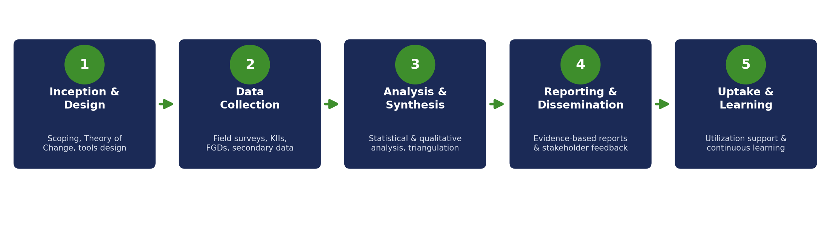
Each stage is underpinned by internationally recognised frameworks — including Theory of Change, the Logical Framework Approach, and Results-Based Management — and is tailored to the context, scale, and objectives of the specific assignment. We place strong emphasis on data quality assurance, stakeholder participation, and the ethical conduct of research throughout.

7. WHY CHOOSE OUTCOMEGRID AFRIKA
Clients choose OutcomeGrid Afrika because we combine methodological rigor with practical, technology-enabled delivery — and because we treat every assignment as a partnership rather than a transaction.

 | Multidisciplinary Expertise  A team spanning M&E, statistics, data science, information systems, and project management.
Proven Methodologies
Application of internationally recognised frameworks and rigorous mixed-methods research.
Technology-Driven Solutions
Digital data-collection tools and AI-enabled analytics that improve speed and data quality.
Local Context, Global Standards
Deep understanding of the East African development landscape paired with global best practice.
Client-Centred Delivery
Responsive, collaborative engagement tailored to each client's needs and timelines.
Capacity-Building Focus
Every assignment is designed to leave clients with stronger internal skills and systems.

8. LEADERSHIP PROFILE

Moses Okalebo — Founder & Managing Director
Moses Okalebo is a monitoring and evaluation practitioner, trainer, and researcher with extensive experience in quantitative research methodology, statistical data analysis, and development-evaluation frameworks across Uganda and the wider East African region. He is a PhD candidate in Information Systems at the University of Nairobi, where his research examines the utilisation of mobile health (mHealth) technologies for adverse-drug-reaction reporting within Uganda's public healthcare system, viewed through an absorptive-capacity lens.
He serves as an instructor and examiner in Monitoring & Evaluation at the Eastern and Southern African Management Institute (ESAMI) and Uganda Management Institute (UMI), supporting postgraduate training in M&E and development studies. Under his leadership, OutcomeGrid Afrika combines academic rigor with hands-on consulting experience across research, evaluation, data analytics, and digital innovation.

Our Team Structure
OutcomeGrid Afrika draws on a core team of technical leads and a wider pool of associate consultants engaged according to the scale and specialisation needs of each assignment.
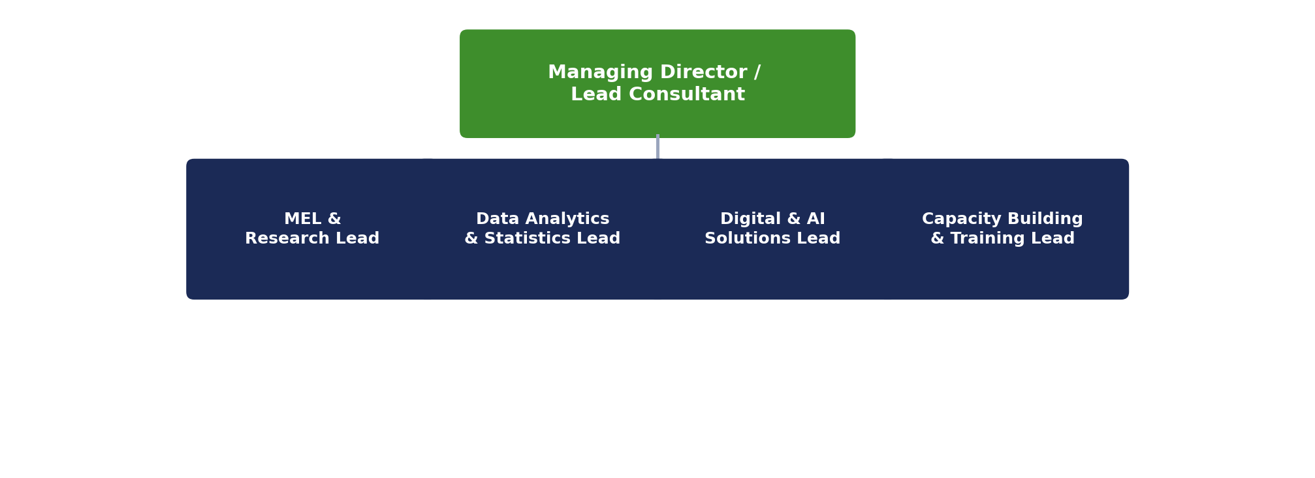

9. SELECTED ASSIGNMENTS AND EXPERIENCE
OutcomeGrid Afrika's team has delivered research, evaluation, and analytics assignments for public-sector, non-governmental, and development-partner clients. A representative sample is provided below; additional references and full assignment histories are available on request.

YEAR | CLIENT / PROGRAMME | ASSIGNMENT | DESCRIPTION
2025–2026 | Kotido District Local Government | Endline Evaluation, Local Revenue Enhancement Programme (LREP) | Integrated qualitative and quantitative findings across six thematic areas, drawing on KII and FGD data alongside quantitative survey analysis.
Ongoing | [Client / Programme Name] | [Baseline / Midline / Endline Evaluation] | [Brief description of scope, methods, and key deliverables]
Ongoing | [Client / Programme Name] | [M&E System Design / Training] | [Brief description of scope, methods, and key deliverables]
Ongoing | [Client / Programme Name] | [Data Analytics / Digital Solution] | [Brief description of scope, methods, and key deliverables]

10. STRATEGIC PARTNERSHIPS
OutcomeGrid Afrika's leadership and technical team maintain active academic, training, and professional affiliations that extend the firm's reach and technical depth. These relationships strengthen the quality and credibility of our research, evaluation, and training assignments.

University of Nairobi | Academic and research collaboration in Information Systems and applied research.
ESAMI (Eastern & Southern African Management Institute) | Training delivery and postgraduate M&E instruction and examination.
Uganda Management Institute (UMI) | Postgraduate M&E instruction, DME programme support, and applied research supervision.
[Development Partner / NGO Name] | [Nature of collaboration — e.g. joint evaluations, technical assistance]

11. CONTACT INFORMATION
We welcome the opportunity to discuss how OutcomeGrid Afrika can support your organisation's research, monitoring and evaluation, data analytics, capacity-building, or digital transformation needs. Please reach out using the details below.

 | P.O. Box 100523, Kasangati, Mutasa Kafeero City, Kasangati Town Council, Wakiso, Uganda
 | +256 772 619 621 / +256 755 019 287
 | info@outcomegridafrika.com | admin@outcomegridafrika.com
 | www.outcomegridafrika.com
Evidence. Insight. Impact.

